Investigate endogenous duration estimates

Parameter estimates

param_initial <- data.frame(
theta_0 = 0.02881745,
theta_1 = 0.02918875,
lambda_g = 6.439774,
lambda_h = 2.298665,
sigma_g = 0.2231302,
sigma_h = 0.2231302,
pi = 0.02990933
)

param_final <- data.frame(
theta_0 = 0.1039761,
theta_1 = 0.126982,
lambda_g = 6.792322,
lambda_h = 2.54617,
sigma_g = 0.1,
sigma_h = 0.1776434,
pi = 0.2441184
)

Likelihood components

Ratio of log likelihoods: final estimates divided by initial values
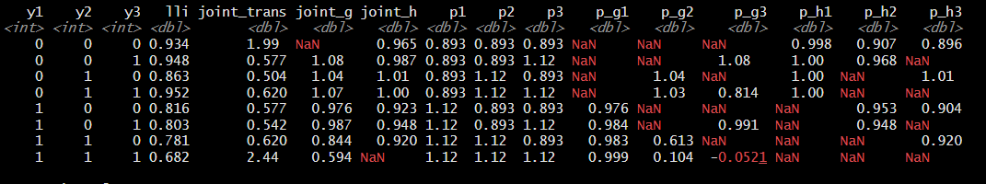
Observations:
- Since log likelihoods are usually negative and larger negative values indicate worse fit, values higher than 1 indicate that Initial Model performs better than Final Model.
- Final model performs worse in fitting employment transitions (to be expected)
  - Driven by much worse fit for consistently employed or unemployed, and despite better fit for churns and much better fit for reverse churns
- Final model performs better in fitting tenure (g) and (to a lesser extent) unemployment duration (h)
  - Similar performance in explaining unconditional (wave 1) duration
  - But final model does better fitting mixed distributions in waves 2 and 3

Wave 1 durations

Tenure
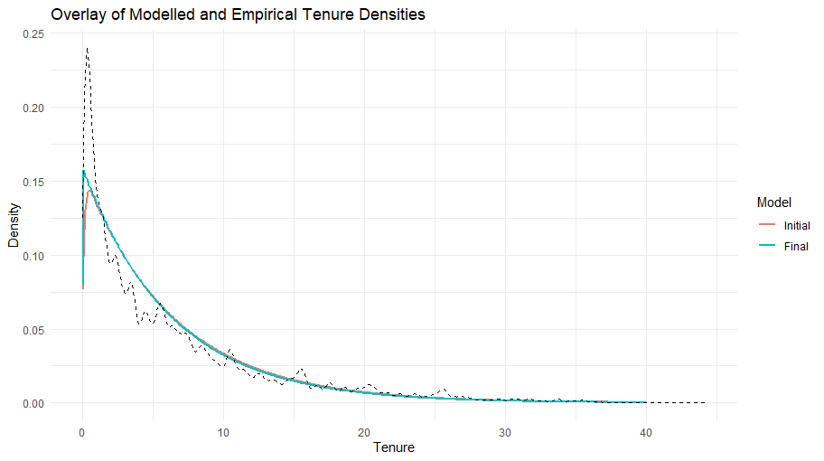

Observations:
- Initial and Final models are quite similar: Initial model has slightly higher mode
- Empirical tenure density has mode that is slightly higher than implied by either model, and lower density in area just above mode.

Specification change:
- Allowing misclassified workers to have a different (i.e. lower) tenure distribution may allow the final model to fit this without requiring higher churn.

Unemployment duration
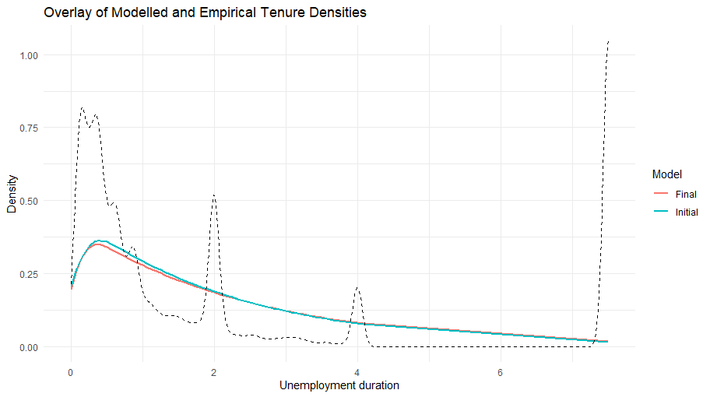

Wave 2 durations

Tenure

There are four hypothetical distributions for wave 2 tenure:
- if $y_{2}^{*}=0$ then $g_{2}$ follows the exGaussian(0, $σ_{g}$, $λ_{g}$) distribution
- if $y_{2}^{*}=1,y_{1}^{*}=0$ then $g_{2}$ follows the n(0.125, $σ_{g}$) distribution
- if $y_{2}^{*}=1,y_{1}^{*}=1 ,y_{1}=0$ then $g_{2}$ follows the exGaussian(0.25, $σ_{g}$, $λ_{g}$) distribution
- if $y_{2}^{*}=1,y_{1}^{*}=1,y_{1}=1$ then $g_{2}$ follows the n($g_{1}+0.25$, $\sqrt{2}σ_{g}$) distribution
The implied densities of these cases for the two sets of parameters are plotted below

Cases 1 ($y_{2}^{*}=0$)

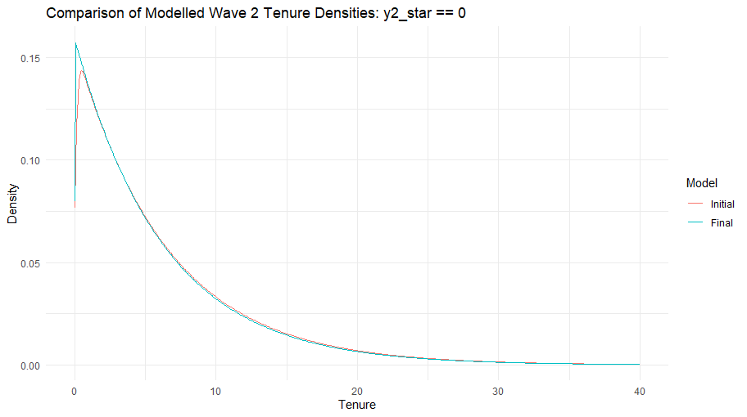Cases 3 (${y_{1}=0,y}_{1}^{*}=1,y_{2}^{*}=1$)

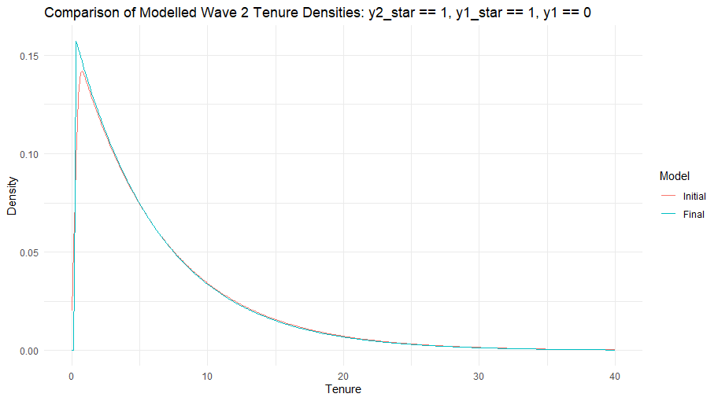

Case 4 ($y_{1}=1,y_{1}^{*}=1,y_{2}^{*}=1$):
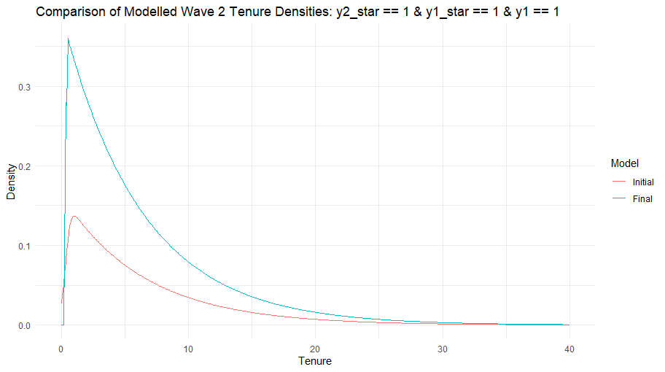

Observations:
- Case 1 looks identical to the wave 1 distribution of tenure, while case 3 is the same curve moved to the right by 0.25 (revealing more of the censored lower tail): Initial and Final models are quite similar, but Initial model has slightly higher mode

Case 2 ($y_{1}^{*}=0,y_{2}^{*}=1$):
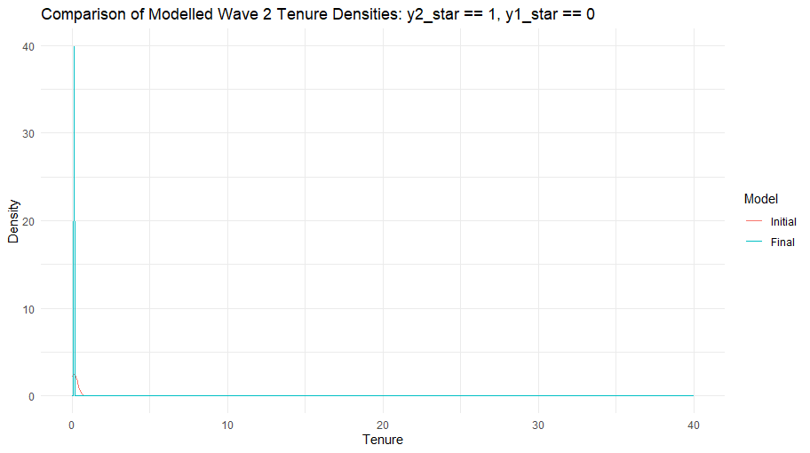

Observations:
- Both models have a mode at 0.125, but the Initial model has more variance around the mode due to the higher estimate of $σ_{g}$

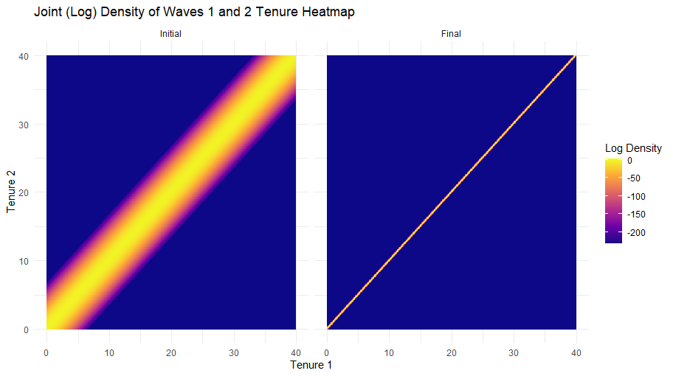

Tenure if $y_{1}=0$
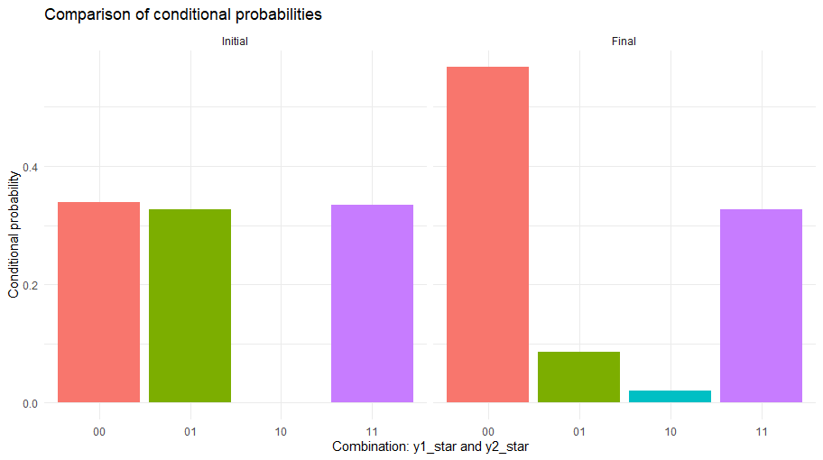
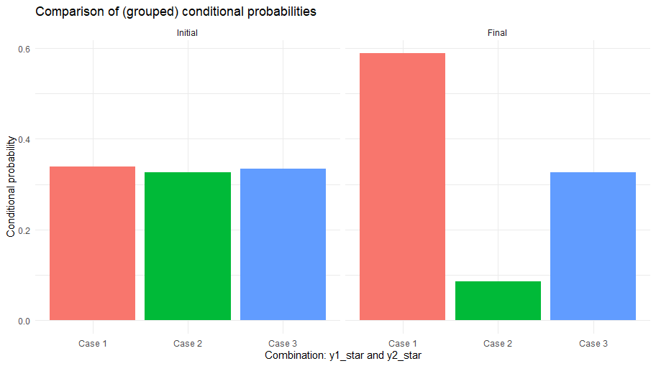

Observations:
- The estimated transition probabilities for Initial Model implies 1) low churn rate and 2) low misclassification probability. Conditioning on $y_{1}=0$ and $y_{2}=1$, the initial Model therefore attaches a relatively high conditional probability to the cases where either there are no misclassification $y_{1}^{*}=0,y_{2}^{*}=1$, or there is a single misclassification but no actual churn ($y_{1}^{*}=1,y_{2}^{*}=1$ and $y_{1}^{*}=0,y_{2}^{*}=0$).
- In contrast, the Final Model estimates imply high churn and high misclassification, so a higher weight is attached to the case where there is two misclassifications
($y_{1}^{*}=1,y_{2}^{*}=0$)

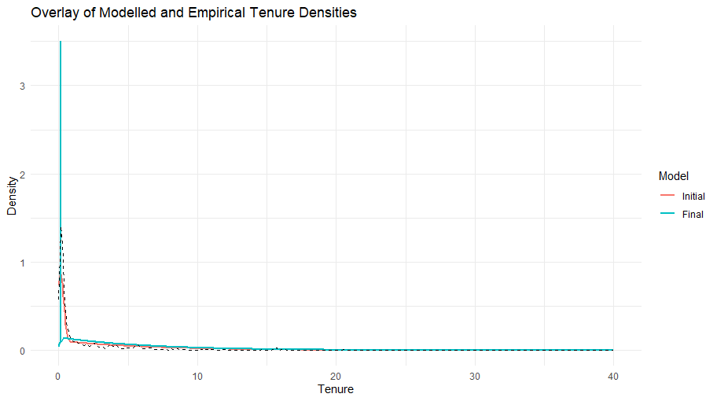
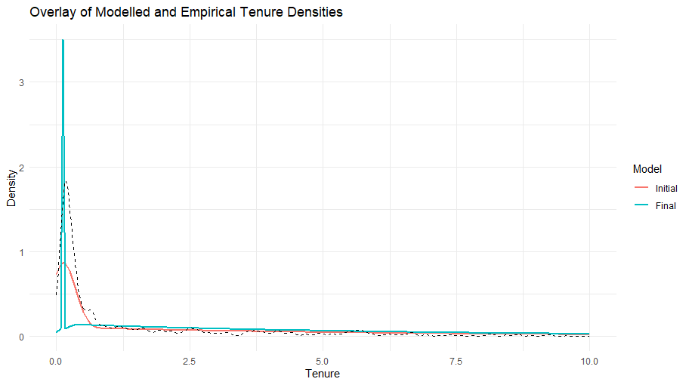
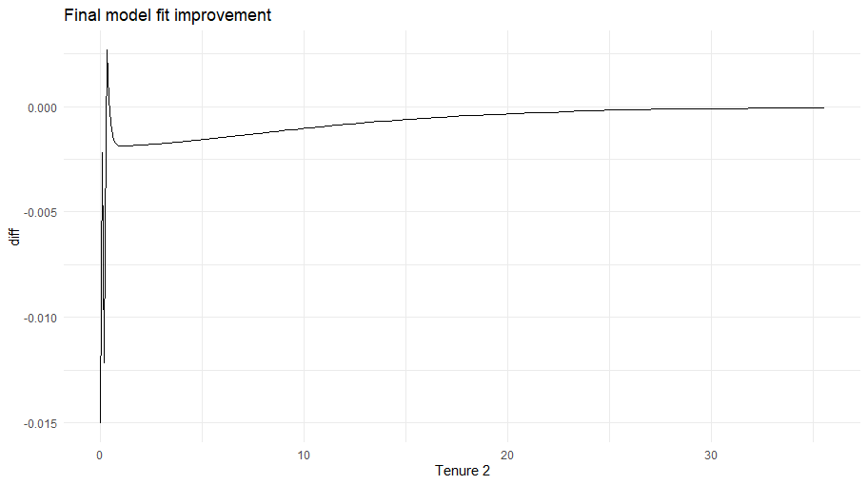

Tenure if $y_{1}=1$
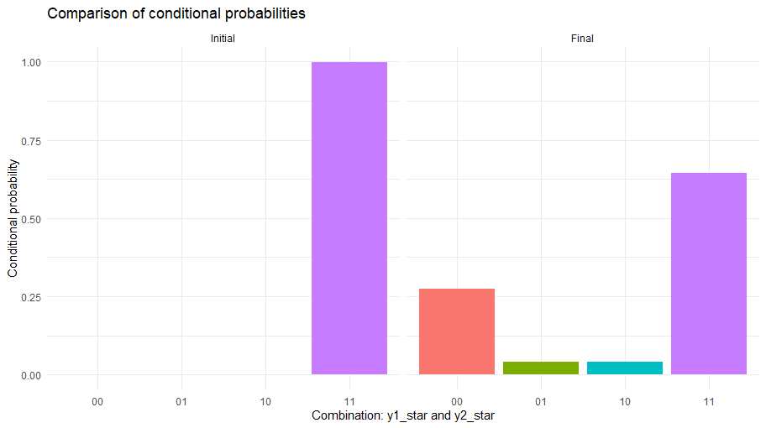
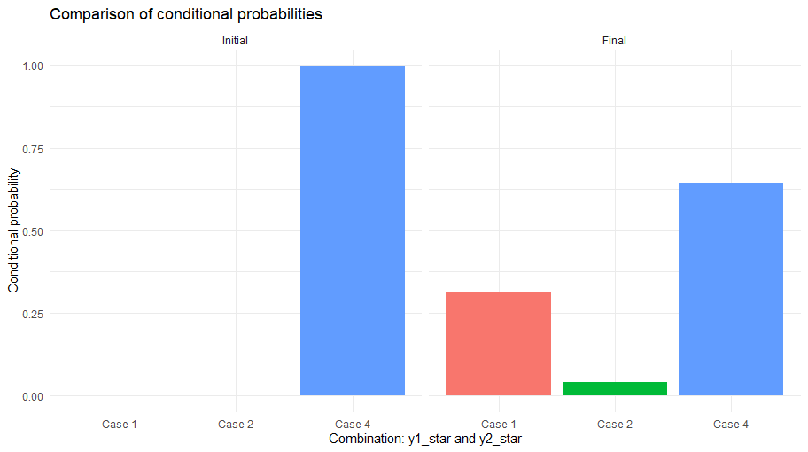

Observations:
- There are more y1 = 0, y2 = 1 workers with close-to-zero wave 2 tenure values than our initial model can explain.
- The final model captures this by estimating higher churn rates than our initial model.
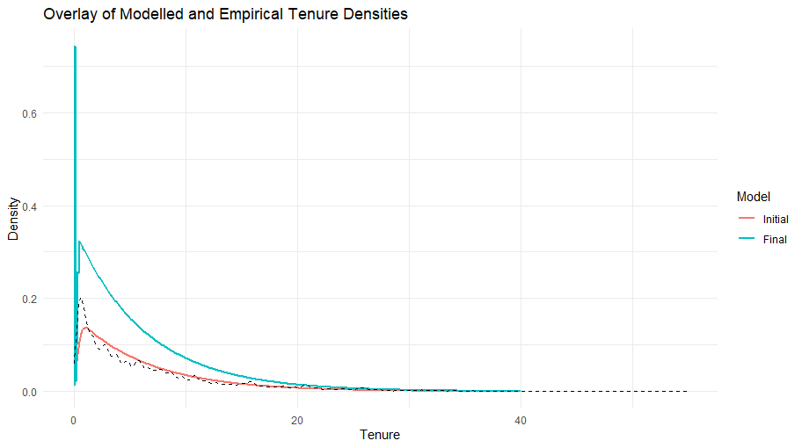
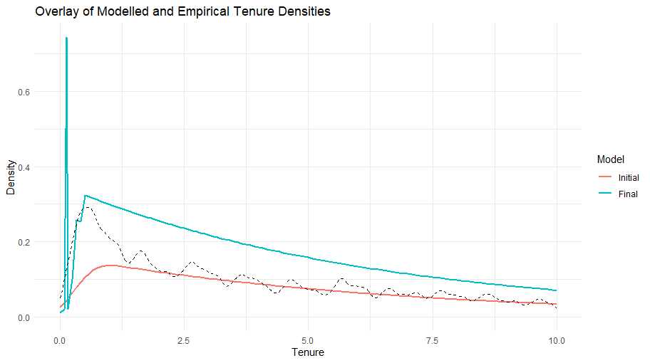

Observations:
- There are more y1 = 0, y2 = 1 workers with close-to-zero wave 2 tenure values than our initial model can explain.
- The final model captures this by estimating higher churn rates than our initial model.

Specification change:
- Allowing misclassified workers to have a different (i.e. lower) tenure distribution may allow the final model to fit this without requiring higher churn.

Tenure if y1 == 1

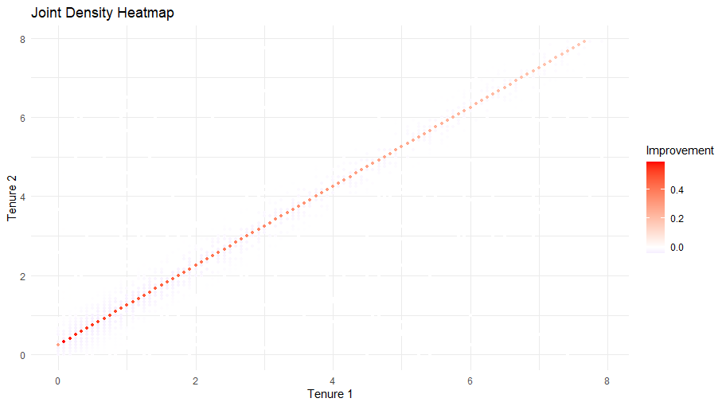

Wave 3 durations

